**ASSIGNMENT 1**

**Submitted by:**

**Aashish Singh**

**Student ID: 23003143**

**Submitted to:**

**Professor: Nawaz Chowdhury**

**Subject: Web Development 2**

**Course code: CSD213**

**Due date: 14 May 2024**

**Table of Content**

**Assignment Steps** 3

**Assignment Steps-1** 3

**Assignments Step-3** 5

**Assignment Step- 4** 6

**Assignment Step 5** 7

# 

# **Assignment Steps**

## **Assignment Steps-1**

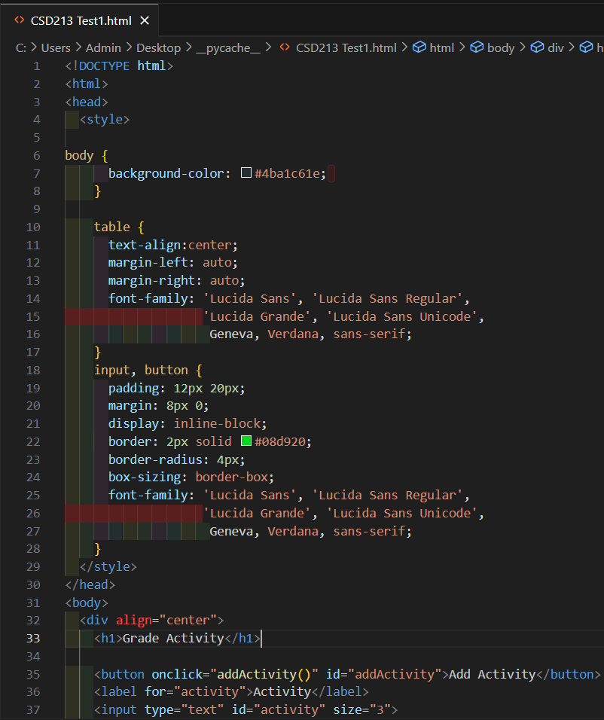

**Assignment Step-2**

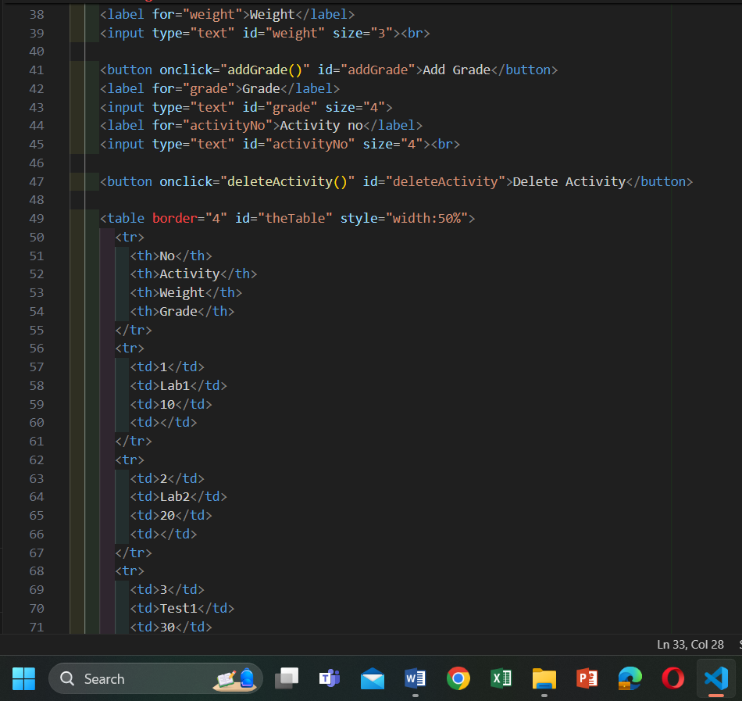

# **Assignments Step-3**

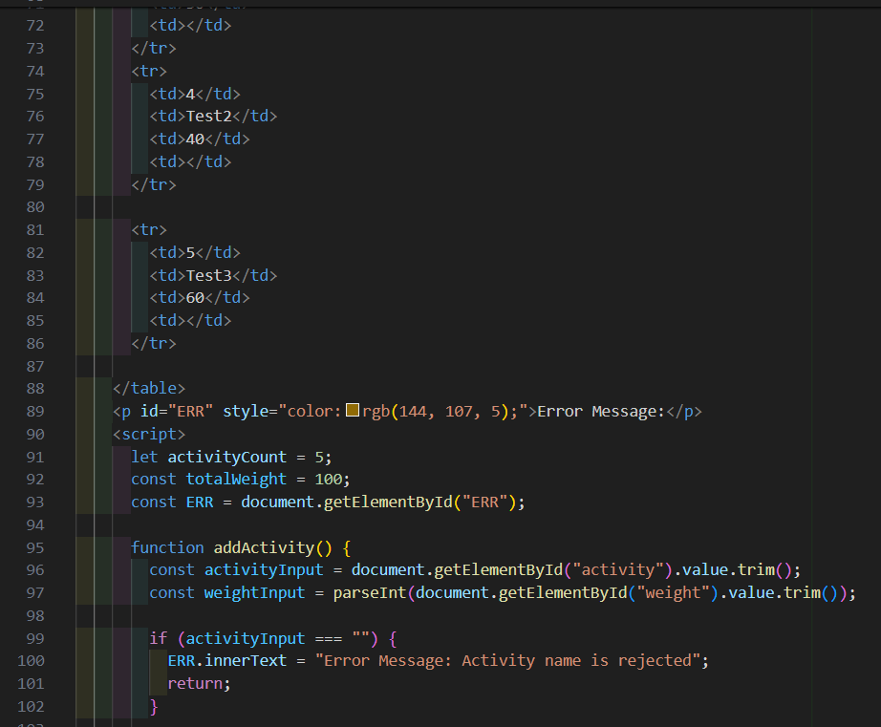

# **Assignment Step- 4**

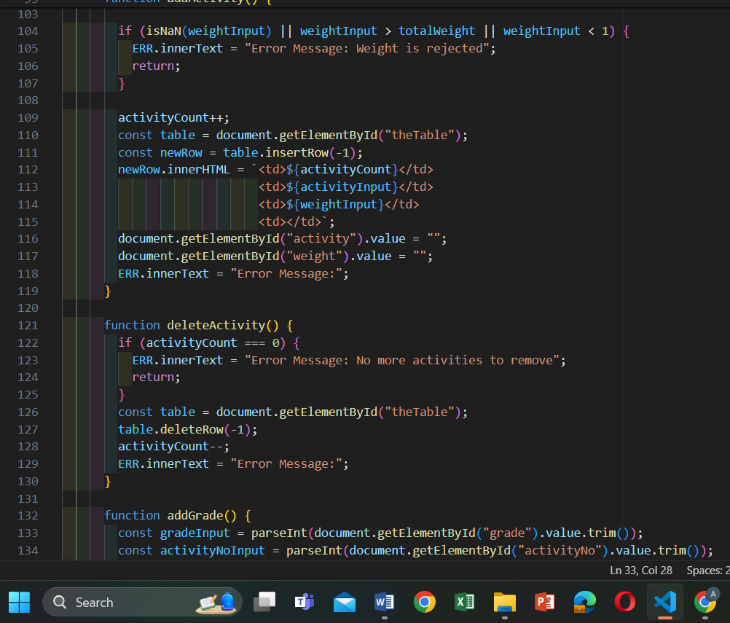

# **Assignment Step 5**

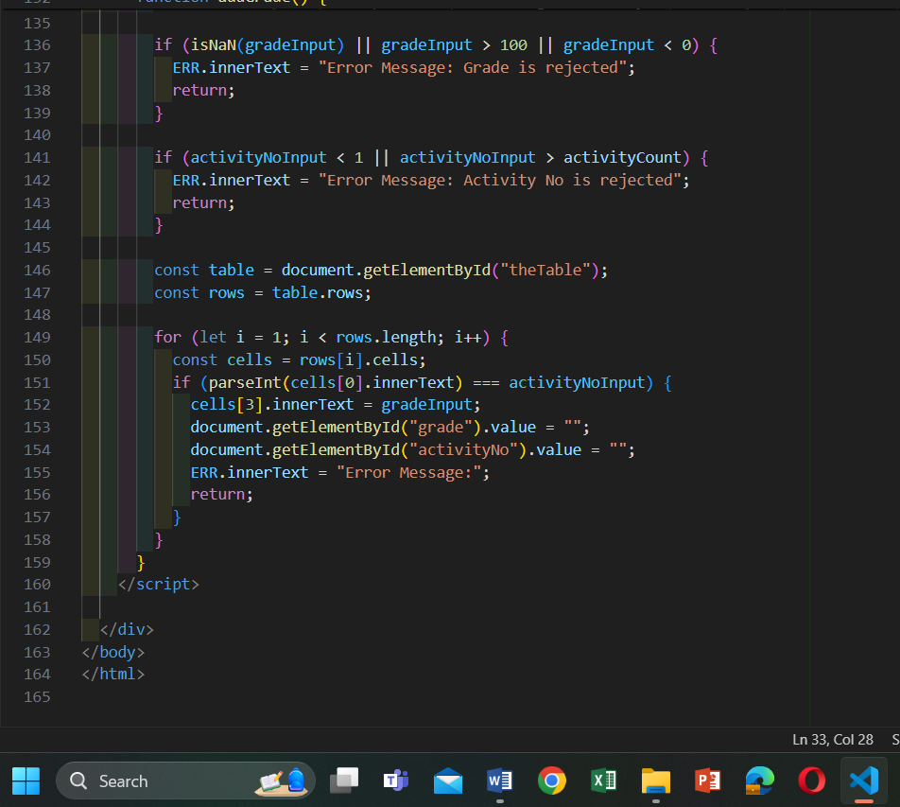

**Output:**

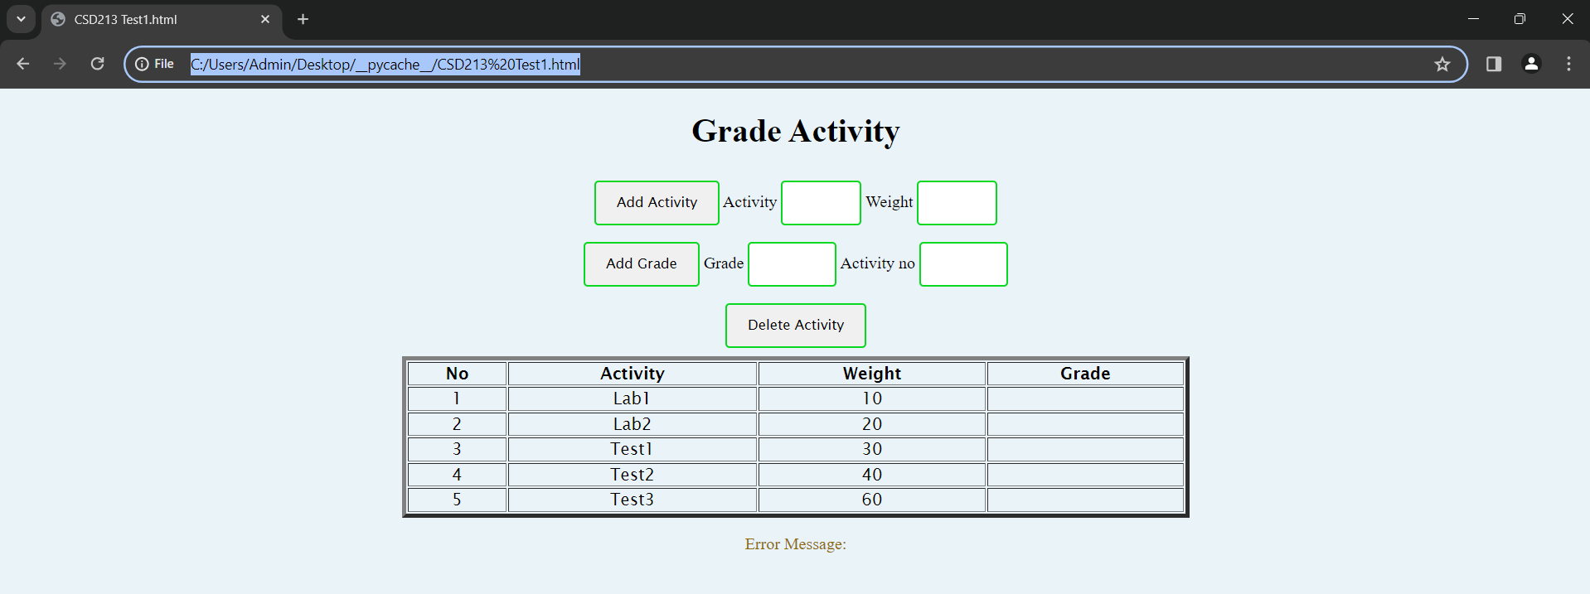

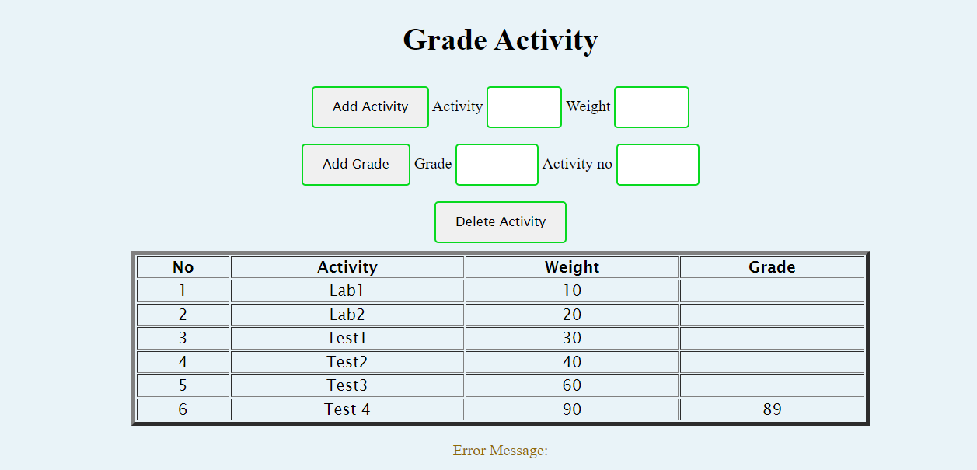

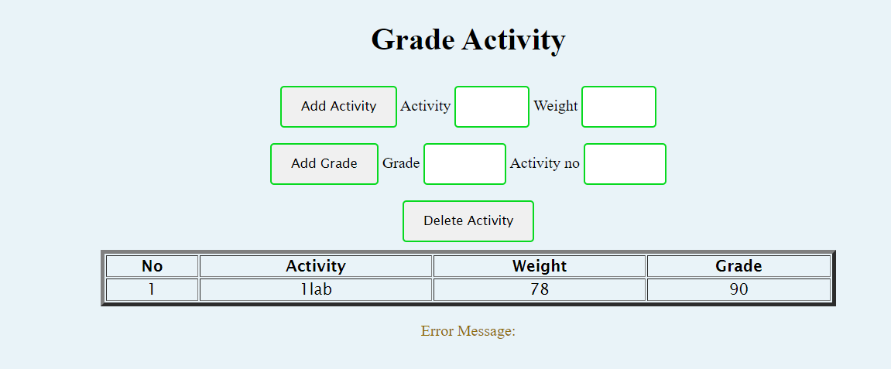

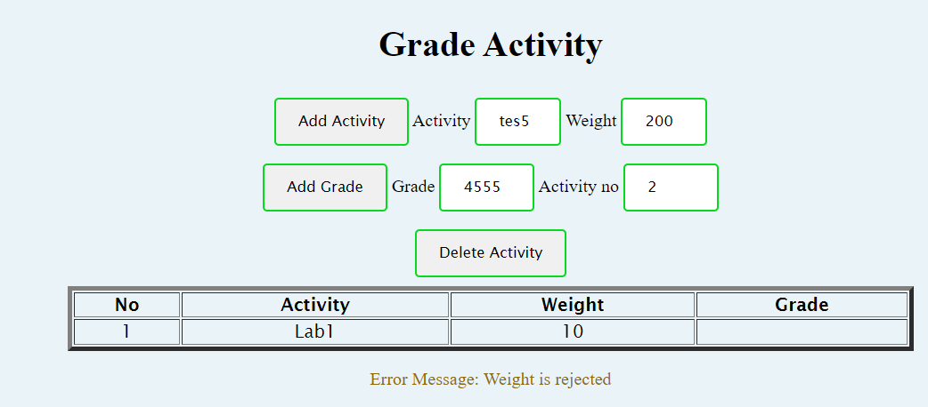

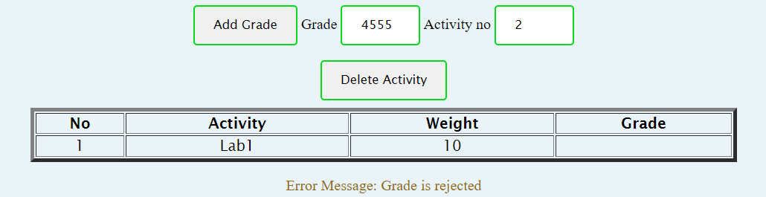

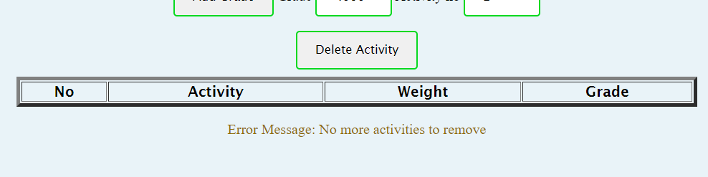

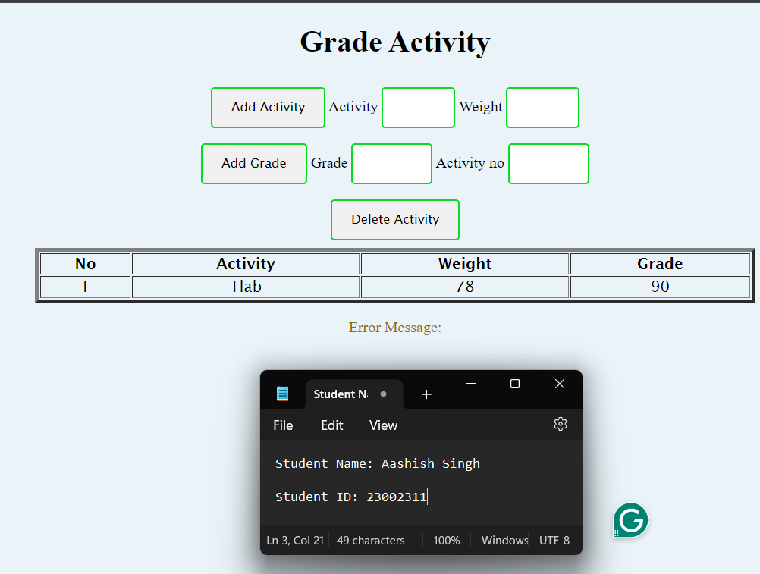

**Reference**

**……………………………………………………………………**